Algonquian Peoples (<http://en.wikipedia.org/wiki/Algonquian_peoples>)

[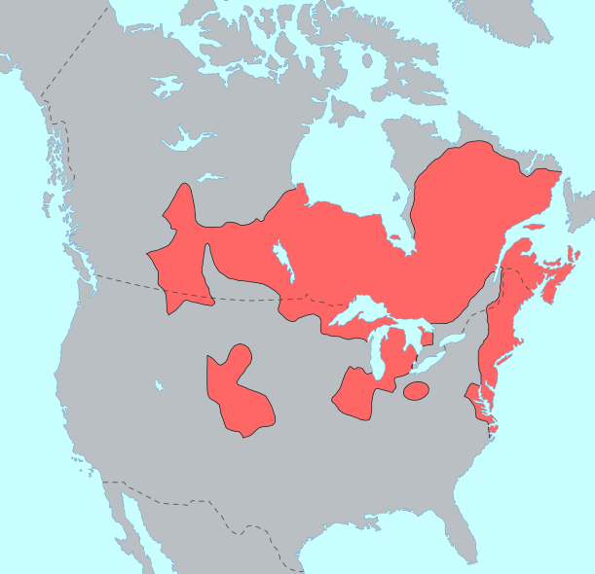](https://stevehollier.files.wordpress.com/2010/10/algonquian_langs.png)

Algonquian language shoken in these areas

Modern Gaelic preserves many spelled letters that are no longer pronounced, but when pronounced in the ancient Gaulish or ancestral tongue of the Celts and Basques, one finds a striking similarity to the Algonquian language.

For example; the Algonquian word for ‘one who takes small fish’ is Amoskeag. In Gaelic Ammo-iasgag means ‘small fish stream’.

In Algonquian Ammonoosuc means ‘small fishing river’ and in Gaelic, Am-min-a-sugh means; ‘small river for taking out fish’.

In Algonquian Coos and cohas mean ‘pine tree’ and in Gaelic, ghiuthas means ‘pine tree’.

Merrimack River in Algonquian means ‘deep fishing’. In Gaelic Mor-riomach means ‘of great depth’.

Kaskaashadi another Algonquian name for the Merrimack River sounds similar to Guisgesiadi, which in Gaelic means ‘slow flowing waters’

Nashaway River in Algonquian means ‘land between’ and in Gaelic naisguir means ‘land connecting’.

Piscataqua River means ‘white stone’ and in Gaelic, Pioscatacua means ‘pieces of snow white stone’.

Seminenal River means ‘grains of rock’, which in Gaelic is; semenaill

Quechee matches the Gaelic work Quithe meaning pit or chasm.

Ottauquechee River flows through a 162 feet deep gorge is similar to the Gaelic word Otha-Cuithe which means; ‘waters of the gorge’.

Cabassauk River in Algonquian means place of Sturgeon. The Sturgeon fish have unfortunately fallen victim to environmental degradation. Similar to Gaelic Cabach-sugh.

Attilah means blueberries and in Gaelic Aiteal means juniper berries.

Munt means people and in Gaelic muintear means people.

Monad means mountain and in Gaelic monadh means mountain.

The suffix – nock is used in New England to denote hills and mountains. Cnoc in Gaelic means hill or rocky outcrop.

Wadjak means on top, in Gaelic the word is uachdar.

Monomonock Lake means ‘island lookout place’ and in Gaelic Moine-managh-ach ‘means boggy lookout place’.

Pontanipo Pond means cold water and in Gaelic Punntaine-pol means ‘numbingly cold pool’

Natukko means cleared place (land) and in Gaelic Neo-tugha means not covered (by vegetation).

Asquam Lake means ‘pleasant watering place’ and in Gaelic Uisge-amail means ‘seasonable waters’.

Advertisements

REPORT THIS AD

REPORT THIS AD

### Share this:

* [Print](https://stevehollier.wordpress.com/2010/10/22/global-whispers-linguistic-links-between-the-algonquian-indian-language-and-gaelic/#print)
* [Facebook3K+](https://stevehollier.wordpress.com/2010/10/22/global-whispers-linguistic-links-between-the-algonquian-indian-language-and-gaelic/?share=facebook&nb=1)
* [Twitter](https://stevehollier.wordpress.com/2010/10/22/global-whispers-linguistic-links-between-the-algonquian-indian-language-and-gaelic/?share=twitter&nb=1)
* [Reddit](https://stevehollier.wordpress.com/2010/10/22/global-whispers-linguistic-links-between-the-algonquian-indian-language-and-gaelic/?share=reddit&nb=1)
* [Email](https://stevehollier.wordpress.com/2010/10/22/global-whispers-linguistic-links-between-the-algonquian-indian-language-and-gaelic/?share=email&nb=1)
* [Google](https://stevehollier.wordpress.com/2010/10/22/global-whispers-linguistic-links-between-the-algonquian-indian-language-and-gaelic/?share=google-plus-1&nb=1)

### Related